|  |
| --- |
| 2024 Hackathon  Resume Renegades Automated  Resume Best Match AI Platform |



Resume Renegade Resume Best Match System.

Enhancing, improving, and automating the talent acquisition tooling.

AI Unleashed, Transforming Everyday Life

Objective

Creating a resume matching system in Google Cloud Platform (GCP) using ChatGPT 4.0. As a team we seamlessly integrated the power of AI-driven language processing with the use of automated workflows and knowledge sharing. By leveraging ChatGPT’s natural language understanding the capabilities within the automation platform you can streamline the process of matching both job descriptions and resumes.

The system can extract keywords such as experience, location, and key skills to help automate the research process for job seekers and recruiters. ChatGPT can then assist this automated process by understanding and interpreting the content, facilitating seamless communication between the user and the system. Additionally, implementing machine learning models can enhance the system’s ability to identify relevant matches by learning past interactions and feedback.

Market Analysis and Research

Competitor offerings vary from site to site. They offer a curated marketplace where companies receive personalized matches of candidates who have already been vetted and are actively looking for new opportunities. Also, by streamlining the hiring process by automatically matching candidates to job openings based on skills, experience, and criteria. Including resume matching technology powered by AI.

Their platform helps recruiters' source, screen, and match candidates to job postings more efficiently. It helps recruiters attract, engage, and hire top talent by matching candidates to job openings based on skills, experience, and cultural fit. Their platform helps recruiters and employers streamline the recruiting process by automatically matching candidates to job openings based on predefined criteria.

Resume Best Match Logistics

How to Create an Automated



Resume Best Match System helps recruiters match relevant resumes to job postings.

Helping improve the recruiter talent acquisition pool.

Matching System

Setting up and Preparing Data

1. **Create a new project.**
2. **Data Hygiene and Preparation** 
   1. Format your data: Ensure that your resumes and job descriptions are in a consistent format, ideally JSON or plain text for easier processing.
3. **Upload Data**: Create a knowledge base where job descriptions and resumes are stored and uploaded.

Creating Matching Parameters

1. **Define Matching Criteria** 
   1. Keywords and Phrases: Simple text matches can be created and saved through simple commands.
   2. Concepts and Topics: ChatGPT requires natural language understanding to identify related ideas and commands even if the exact words are not used in the resumes and/ or job descriptions.
   3. User Preferences: Matching can be based on user data, ultimately requiring a way to compare user inputs or profiles for similarity.
2. **Choose an Approach** 
   1. Create a Rule-Based System: Define your requirements, you can leverage a rule-based system to perform matches based on predefined rules you have chosen.
3. **Implement the System** 
   1. Data Collection: Gather data relevant to your matching criteria. You will collect resumes and job descriptions.
   2. Preprocessing: Ensure your data is clean and ready to be processed. This is where you ensure the resumes and job descriptions are the same file type.
   3. Model Training (if applicable): If you choose to use machine learning, train your model on the collected data, optimizing for accurate identification of matches according to your criteria listed.
   4. Development and Evolution of Rules (if applicable): For rule-based systems, develop the logic and rules that will guide and outline the matching rules. You will define these in the command prompts.
4. **Testing and Integration** 
   1. Evaluate Performance: Test your system to evaluate how well it matches according to your criteria. You can have quantitative and qualitative metrics to test your data and receive instant feedback. Ensure you have tested multiple different scenarios to ensure there are no errors in your matching system.



Resume Generates Real-Time Matches and Feedback

The users can upload job descriptions or resumes and get real-time feedback and matches.

1. **Iterate**
   1. Based on the performance and feedback, iterate your system. This might involve adjusting rules, retraining models, or refining the matching criteria. This will be one of the longer steps where you ensure there is no errors within the matching criteria.
2. **Integration** 
   1. Once you have created and adjusted your system you can ensure it can access the necessary inputs and provide useful outputs based on matches. This happens after the user testing is complete and the system is running on no errors.
3. **Additional Features** 
   1. Users can upload resumes or job descriptions for real-time analysis and feedback.
   2. Users can receive career development advice, including identifying skill gaps for desired job roles and suggesting resources for professional growth.
   3. If a candidate asks for a resume review and attaches their resume, a detailed review of their resume will be given. It can highlight strengths, identify areas for improvement, and suggest matches based on the matching analysis.
   4. A candidate can ask for a resume review in relation to a specific job description and must attach their resume with the job description. The system will highlight strengths, identify areas for improvement, and suggest matches based on the analysis.
   5. If the user types something you don't understand or are unable to answer, type 'I don’t understand your request. Please try again '.

Test Case Examples and Explanations

1. **Software Engineering**
   1. Positive Match: Expertise in Java, Spring Boot, and Docker with 3 years of experience yields a 95% match for senior developer roles.
   2. Negative Match: A background in Cobol and Mainframe with 20 years of experience results in a low match due to demand shifting towards modern technologies.
   3. Edge Case: Specialization in Python, AI, and Machine Learning with a PhD aligns well with AI research roles, though opportunities are niche.
2. **Marketing**
   1. Positive Match: A digital marketing skill set including SEO and Google Analytics over 5 years matches 98% with digital marketing manager roles.
   2. Negative Match: Experience in traditional marketing with print ads shows a low match, highlighting a market shift towards digital skills.
   3. Edge Case: Knowledge in social media, emerging platforms, and viral marketing, despite only 2 years of experience, is highly desirable in the evolving digital marketing landscape.



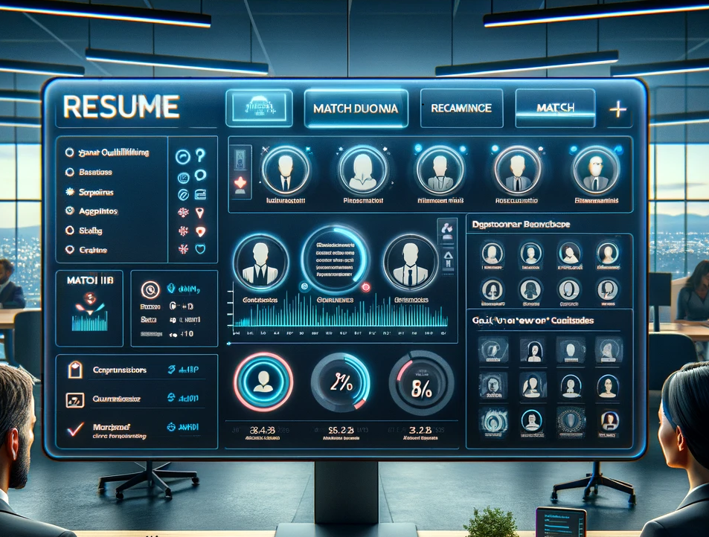

Improved Candidate Experience

Personalized Recommendations: For job seekers, it can provide personalized job recommendations based on their skills and experiences enhancing their job search experience.

1. **Healthcare**
   1. Positive Match: A Registered Nurse with critical care experience and BLS/ACLS certification perfectly fits critical care nursing positions in high-demand areas.
   2. Negative Match: Medical billing experience with outdated ICD-9 certification results in low match scores, suggesting a need for updating qualifications.
   3. Edge Case: Experience in telehealth nursing, even just for a year, matches well with the growing field of telehealth, highlighting the potential despite limited experience.

Resume Renegade Matching Assistant Feedback Form

Date: ___________________________

Role:

[ ] Recruiter

[ ] Candidate

Ease of Use:

[ ] Very Easy

[ ] Easy

[ ] Neutral

[ ] Difficult

[ ] Very Difficult

Satisfaction with Matches:

[ ] Very Satisfied

[ ] Satisfied

[ ] Neutral

[ ] Dissatisfied

[ ] Very Dissatisfied

Speed of Service:

[ ] Very Fast

[ ] Fast

[ ] Acceptable

[ ] Slow

[ ] Very Slow

What did you like?

________________________________________________________________________

What could be improved?

________________________________________________________________________

Would you use this service again?

[ ] Yes

[ ] No

Additional Comments:

________________________________________________________________________

Thank you for your feedback!

Comprehensive Insights





Continuous Review and Improvements

The automated matching model can be retrained at any point in time. Updates can be made as often or not as possible.

* **Upskilling and Reskilling**: Negative scenarios reveal the need for professionals to continuously update their skills in line with industry trends and technological advancements.
* **Niche Specialization**: Edge cases highlight how specialized skills in emerging fields or technologies can offer unique opportunities, though they may come with challenges related to experience levels or niche market sizes. These merged scenarios demonstrate the assistant's capability to provide nuanced feedback and job matching services tailored to the unique demands and shifts within various sectors. The assistant effectively guides users—whether they're seeking to improve their job prospects through upskilling, transitioning to new industries, or finding their place in niche markets.

Key Features of an Automated

Resume Match System

Incorporating ChatGPT into our resume matching system can significantly enhance the capabilities of these systems, leveraging the advanced natural language understanding and generation features of this AI Matching Model.

Here are key features and how they can be applied to resume matching systems:

1. **Understanding Complex Criteria**: The model can interpret and analyze complex job descriptions and resume content and requirements to ensure candidates are matched to positions that suit their skills and experience.
2. **Holistic Profile Awareness**: ChatGPT 4.0 can consider the entirety of a candidate's resume in context, allowing for a more comprehensive assessment of their fit for a role.
3. **Dynamic Query Understanding**: It can handle dynamic queries from employers, adapting to specific requests or preferences in candidate selection, and refine search results based on feedback or additional criteria.

Matching Mechanisms

Developing a Matching Mechanism

1. Design your matching criteria: Use the keywords needed for matching, such as skills, experience level, location, role, and education.
2. Use the deployed models: Utilize your models to analyze resumes and job descriptions, extracting and comparing relevant keywords.

Continuous Review and Improvements

1. Monitor matches: Regularly review the matches made by your system to ensure they meet your expectations.
2. If needed, retrain your models: As you gather more data, retrain your models to improve their accuracy and efficiency of the matches.
3. Secure and Manage Your System



Resume Matching System is Flexible and User-friendly

The automated system can adapt and change depending upon the users needs and any changes in requirements.

* 1. Monitor your GCP resources: Keep an eye on your system's performance and costs using GCP's monitoring tools.

Key Takeaways

* **Documentation**: Keep thorough documentation of decisions, design iterations, and user feedback.
* **Communication**: Maintain clear and open communication across the team, using collaboration tools for quick updates.
* **Prioritize**: Always keep the user's needs at the forefront and prioritize tasks that directly contribute to improving the user experience and addressing their problems. Ensure testing is done throughout the build of your matching system and after to ensure it is creating a positive user experience.
* **Flexibility**: Be ready to pivot or adapt your approach based on feedback and testing results. No-code development is iterative, and flexibility can lead to an overall better final product.
* **Division of Labor**: Ensure tasks are clearly defined but allow for collaboration between roles. For instance, the designer might need to work closely with the developers to ensure the feasibility of UI elements, and the content strategist might need input from the technical lead to understand feature capabilities for accurate content creation.

Presentation Preparation

* **Clear Roles**: Assign specific sections of the presentation to each team member, playing to their strengths and areas of contribution. This ensures a well-rounded presentation that covers all aspects of the matching system presentation.
* **Storytelling**: Structure your presentation as a story, beginning with the problem you identified, followed by how your solution addresses it, what you've achieved during the hackathon, and ending with future directions and how user feedback has shaped your project.
* **Demo Preparation**: Ensure the demo is concise but impactful. Highlight the core functionalities and the user journey.
* **Technical Check**: Before the final presentation, conduct a technical rehearsal to ensure all equipment and software work as expected. Test screen sharing the matching system on the no-code platform.
* **Feedback Incorporation**: After each rehearsal, gather feedback from your team members to improve the delivery, clarity, and effectiveness of the presentation. Pay special attention to time management to ensure you stay within the allotted time.

Final Thoughts

* As a Technical/No-Code Lead, your role is crucial in laying the technical foundation for your project. By carefully selecting the right no-code platforms and ensuring the team is up to speed on their functionalities, you set the stage for efficient and effective development and allow for an effective and great user experience.

Future Iterations

* Verification and Validation: Currently, it can't verify the accuracy of the information in resumes or job listings or validate the qualifications of candidates and the legitimacy of job openings.





Communication is Key

The automated matching model can match resumes and job descriptions using key words to create a positive user experience for the recruiter and candidate.

* Direct Communication: Currently, it cannot facilitate direct communication between job seekers and employers or participate in the hiring process beyond matching based on keywords.
* Dynamic Interaction Models: Develop a more conversational interface where users (both candidates and job recruiters) can be asked clarifying questions to better understand the users needs and preferences. This will enable the matching process to generate more relevant matches based on the questions asked.
* Enhanced Natural Language Processing (NLP) Capabilities: Improving the chatbot's ability to understand and process user queries in natural language can make interactions more intuitive and efficient. This includes better recognition of various job roles, skills, qualifications, and industry jargon.
* Machine Learning Algorithms for Improved Matching: Incorporating machine learning algorithms can enable the chatbot to learn from interactions and improve its suggestions over time. This could include learning from successful matches to refine how it evaluates relevance and compatibility between resumes and job listings.
* Personalization and User Profiles: Allowing users to create profiles where they can save preferences, job searches, and application statuses. The chatbot could use this information to provide more personalized recommendations and updates on new opportunities matching their profile.

Career Development and Skill Gap Analysis: Implementing a feature that offers career development advice, including identifying skill gaps for desired job roles and suggesting resources for professional growth. This could help candidates improve their employability and align their skills more closely with their career goals.

* Confidentiality and Data Security Features: Highlighting the chatbot's commitment to user privacy and data security can build trust with users. This includes transparently communicating how user data is used and protected.
* Interactive Workshops and Webinars: Offering scheduled interactive sessions on topics like resume building, interview preparation, and career planning can add value for users, making the chatbot a comprehensive career development tool.

These features can significantly enhance the effectiveness of the chatbot, making it a more valuable tool for job seekers and recruiters alike.